**How to add a new player to your Respect in Sport Profile**

**Step 1**

Go to the [Respect in Sport Parent](https://omhahockeyparent.respectgroupinc.com/) web site

**Step 2**

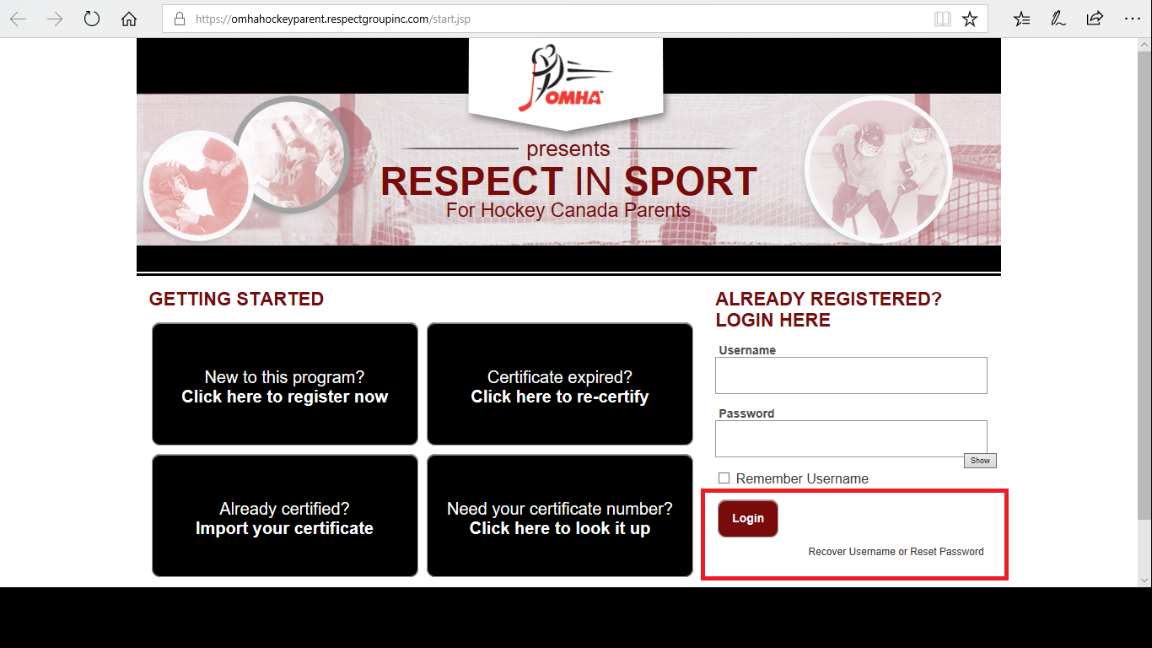

**Step 3**

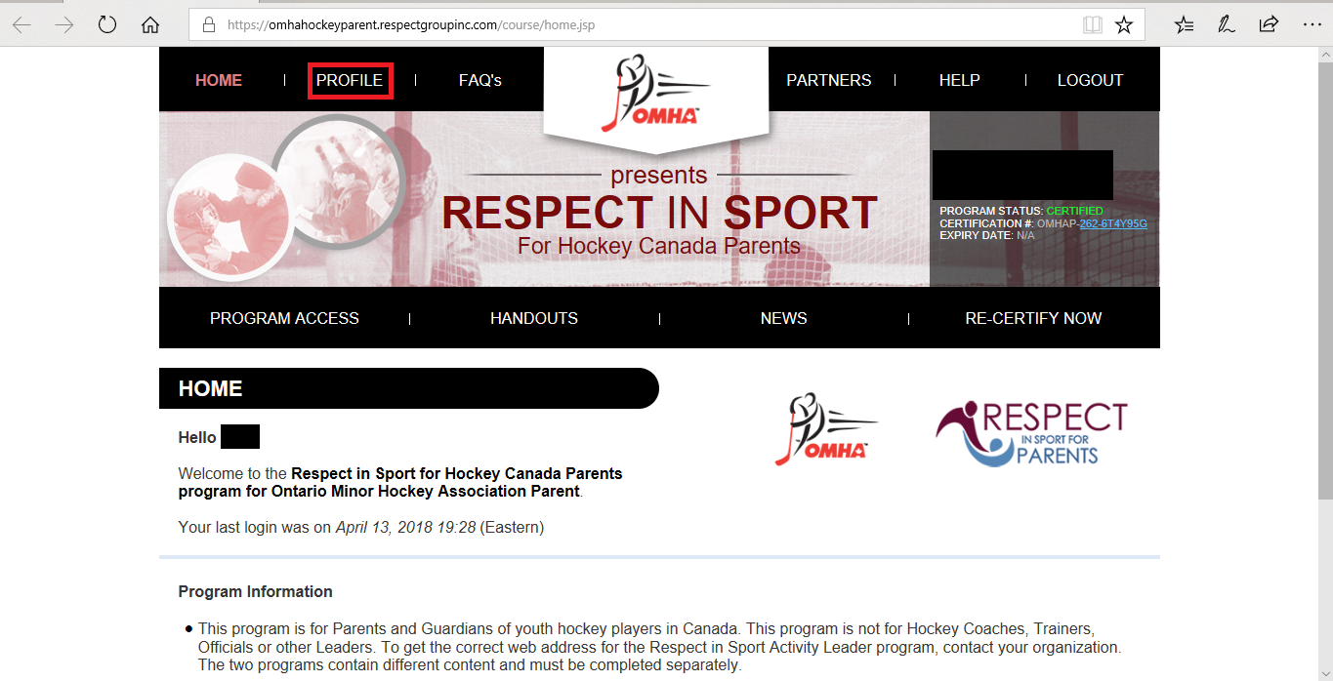

**Step 4**

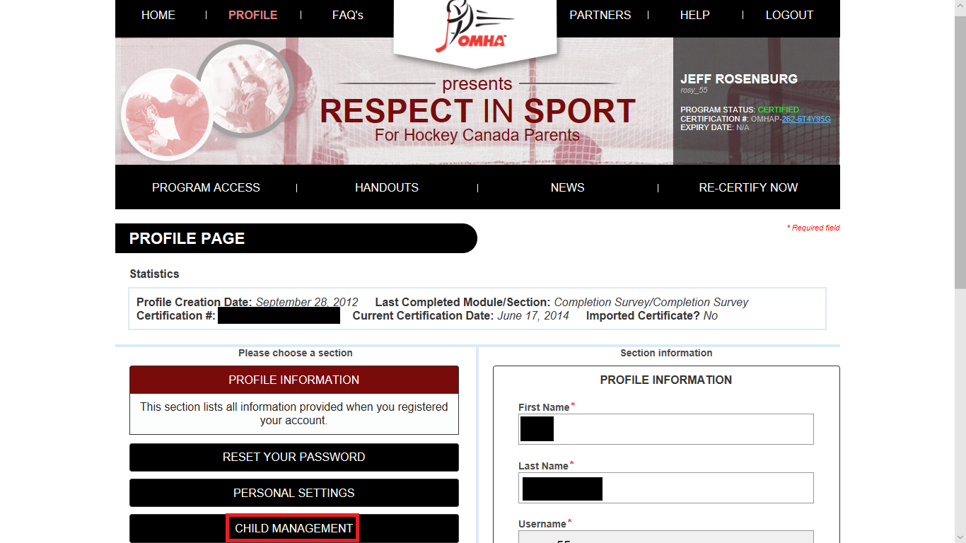

**Step 5**

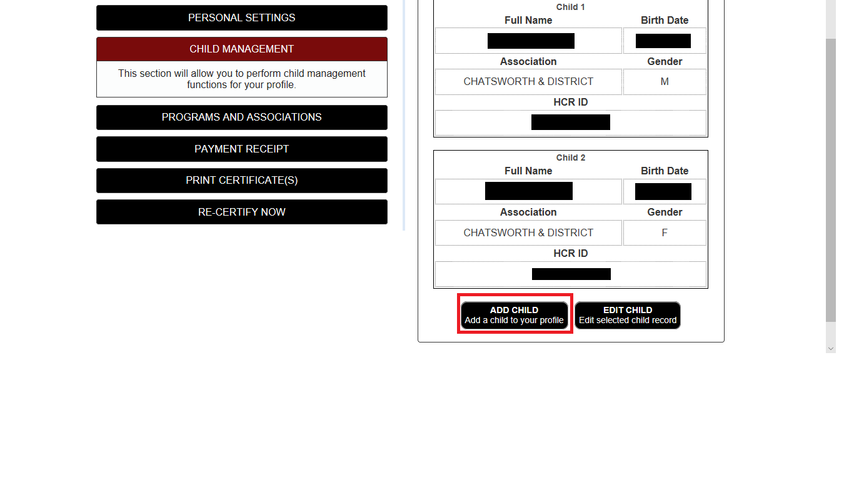

**Step 6**

